PROJECT JAM SHOLLAT ARDUINO

*Dev.RayOcta303 || OctaZoneID*

WIRING DISPLAY

|  |  |
| --- | --- |
| KABEL P10 | Arduino Board |
| Pin 1 | Digital 9 |
| Pin 2 | Digital 6 |
| Pin 3 | GND |
| Pin 4 | Digital 7 |
| Pin 8 | Digital 13 |
| Pin 10 | Digital 8 |
| Pin 12 | Digital 11 |

*DIAGRAM SOKET/KABEL P10*

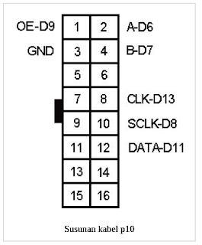

WIRING MODUL RTCds 3231 Wiring Tombol untuk setting

|  |  |
| --- | --- |
| RTC | ARDUINO |
| GND | GND |
| V IN | V IN |
| SDA | A4 |
| SCL | A5 |
| 32k | --- |
| SQW | --- |

|  |  |
| --- | --- |
| BUTTON INPUT (UNTUK SETTING RTC) | ARDUINO |
| UP | A3 |
| MENU | A2 |
| DOWN | A4 |
| GND [UP,MENU,DOWN] | GND |

Wiring Buzzer Active 5v

|  |  |
| --- | --- |
| BUZZER | ARDUINO |
| Positive + | Digital 2 |
| GND | GND |

